**Table of Contents**

Team Biographies (Team) 2

Executive Summary (Team) 3

**Section I: Target Audience Profile** 5

Target Audience Profile (Team) 6

**Section II: Creative Platform** 11

Creative Platform (Team) 12

Core Message (Team) 13

Quantitative Objectives (Team) 13

Campaign Evaluation (Team) 15

**Section III: Creative Strategy**  16

Overview of the IMC Plan (Team) 17

Executive Principles of the Creative Platform (Team) 19

Presentation and Analytical Critique of Logo and Layouts (Team) 21

**Appendices** 32

Appendix A: In-Depth Interview Method and Results (Jocelyn) 33

Appendix B: Copy-Test Method and Results (Stephanie) 38

**Team Biographies**

***Stephanie Aronson*** is a student at Illinois State University studying Marketing with a sequence in Integrated Marketing Communications and minoring in Organizational Leadership. Through her studies at this university, she has had the opportunity to learn all the different aspects of marketing but more specifically on how to get the many message out to the public and being consistent with it. She has learned about online marketing, advertisement critiquing, marketing research, etc. Stephanie has been able to apply her knowledge through her internship that she had held at Marketing Masters NY. Through her internship she was able to not only gain more knowledge on social media marketing, but she gained knowledge on the importance of note taking and applying it to creating press releases.

***Robert Dowling*** is a college student at Illinois State University, majoring in Marketing. His aspirations is to work in the marketing/advertising field upon graduation. Through his studies at Illinois State University, Robert has enhanced knowledge and technical skills from course work that gained him necessary field experience. He has learned about sports marketing, advertising, multi-media marketing, event planning, promotions, etc. From the experience of his studies, he landed a summer internship with Morgan Stanley in Chicago. From his experience, Robert has gained valuable insights and knowledge from a corporate environment through marketing research companies for potential clients to invest in.

***Tori Howard*** is currently a senior at Illinois State University working towards a degree in Marketing with a specialization in Integrated Marketing Communications. Victoria has developed IMC related skills during her time at ISU. After completing several marketing classes such as Creative Strategy and Design and Foundations of Integrated Marketing Communications, Victoria has become skilled in Adobe Illustrator and Adobe Photoshop, while learning how to perfect a marketing campaign. While still building her IMC resume, Victoria is currently continuing her education until her graduation date in May of 2016.

***Jocelyn Perez*** is a senior at Illinois State University studying Marketing with a sequence in Integrated Marketing Communications. Through the courses at Illinois State University Jocelyn has learned many important concepts related to Integrated Marketing Communications. She has learned how to create an effective message and what the best way is to get it to the target audience. She has also learned how important it is to create consistent campaigns to really reach the target effectively. She has learned a great deal about mobile marketing, creating campaigns, creating effective messages, and appealing to a target audience.

**Executive Summary**

Gene’s Dairy Delights & More is an ice cream place located in Bloomington, IL right off Main Street. This company has many competitors whether is small ice cream businesses or even the well-known ice cream chains. These major competitors are Carl’s Ice Cream, Cold Stone, and Emack & Bolios. Gene’s has had a hard time developing a well-known logo and their current one is outdated and uninteresting. Gene’s also lacked a social media site presence and an informational website.

The target market profile includes two similar yet different markets, the primary market and the secondary market. The primary market for Gene’s is the Bloomington Community. These were chosen because it is close to the heart of Bloomington and ice cream is a very family oriented food product. The psychographic characteristics of the primary target market includes:

* Family bonding
* Support the community
* Enjoy leisure time
* Enjoy a quick convenient shop
* Prefer local businesses vs. Franchise

The secondary market for this campaign is focused on the students in the colleges around the Bloomington-Normal area. The students were chosen as the secondary because Gene’s is in Bloomington, but not located very close to the students who we assume like to walk everywhere. The psychographic characteristics of the secondary target market includes:

* Support the community
* Quick and convenient trips
* Evening out with friends
* Prefer cheaper options
* Prefer small local shops versus franchise

The campaign objectives for this campaign include quantitative objectives including communication objectives and sales/behavior objectives. The communication objectives are the following:

* Increase brand awareness of Gene’s Ice Cream
* Make Gene’s ice cream part of our targets evoked set.

The sales/behavioral objective of the campaign are the following:

* Increase Sales
* Increase amount of traffic during after dinner hours by 30%
* Increase website hits and awareness
* Increase Facebook Likes
* Create a Twitter

The main creative platform goal we want to accomplish is to increase awareness of Gene’s and to let the consumers know that they serve more than just ice cream. The secondary goal for the campaign is to make Gene’s apart of our target audience’s evoked set. The campaign will be focused on how Gene’s offers ice cream, hot dogs, shakes and other items not related to ice cream. We also want to include that the prices for Gene’s items are very inexpensive but are quality.

There are five layouts chosen to be used in this campaign. These layouts were chosen to accomplish communication and sales objectives. The layouts included:

* Direct Mailer
* Reward Card
* Door Hanger
* Magnet
* T-Shirt

The copy test done for this campaign was done for one of the layouts. The copy test revealed that consumers had gotten the message that Gene’s did serve more than just ice cream items. The copy test also revealed that the customers were more prone to go to Gene’s if that had the direct mailer with the 30% off instead of not having that on the layout.

The Creative Strategy is perceived to very effective and beneficial to Gene’s. We expect sales to rise in a short time because we have planned the layouts in specific times of the year. The promotion materials will help Gene’s a lot because this will help create a lot of awareness around the Bloomington-Normal area and help bring Gene’s in the evoked set of the primary target market. The materials provided will direct customers to Gene’s social media pages (Twitter and Facebook) and it will also lead them to the exact location of Gene’s because we provide a visual map of where Gene’s is located.



Section I:

Target Audience

5 | Page

**Target Audience Profile**

    Gene’s Dairy Delight is a small, family-owned ice cream shop located in Bloomington, IL. Gene’s has ice cream and other tasty treats that accommodate the price conscientious consumer, without compromising their great quality. Gene’s differs from other ice cream shops, because it has a drive-up and order format, which is quick and convenient for customers who are always on the go. However, Gene’s offers outdoor seating for friends and families who would like to sit and enjoy their treats.

The customers that most generally visit Gene’s, are middle-aged adults accompanied by their families, consisting of children of all ages. Gene’s recognizes that their primary target audience will ultimately be composed of these suburban families. These Bloomington families are located most conveniently to Gene’s Dairy Delight, and will be the most frequent and consistent customers to the shop. Gene’s focus regarding their primary target is to change the consumers’ perceptions in order to be included in the evoked set of Bloomington residents. Refer to Exhibit 1 for a summary of the proposed target audience for the campaign.

Along with Gene’s primary target audience, there is also a secondary target audience that includes college students from Illinois State University, Illinois Wesleyan, and Heartland Community College.. A detailed description of the complete proposed target audience for the campaign can be found in Exhibit 1.

Since Gene's is located in Bloomington, it is clear that our primary target audience should focus on the head of the household, starting from the age of 25 extending to 65 years old. These ages have been chosen based on the “average” Gene’s consumer. This primary target audience centered in Bloomington, IL. Includes a population of 78,780 people [1].

Along with this proposed target audience, Gene’s will also focus on college students as their secondary target audience. The secondary target audience includes 20.615 students from Illinois State University [2], 1,893 students from Illinois Wesleyan [3], and 5,324 students from Heartland Community College [4]. The age range of these secondary populations has been determined to be 18 to 25, the general age of most college students. We expect the secondary target audience to benefit Gene’s since they are looking for cheaper alternatives to commercial ice cream chains and a relaxing environment in which they can socialize.

**Primary Target Audience**

    The primary target audience of Gene’s Ice Cream consists of the residents of Bloomington, IL. These Bloomington residents are located nearest to Gene’s and, therefore, are the most appropriate choice for the primary target market. Along with location, Bloomington residents generally consist of middle-aged adults and their children. Due to this large amount of families located near Gene’s we are putting more emphasis on Gene’s being a family-friendly establishment. As shown in Exhibit 1, the primary target audience that we will be focusing on has a population of nearly 79,000 residents, most of whom are married, again supporting the idea of marketing Gene’s as a family-friendly establishment [1].

    Bloomington residents have a median income of $61,664 per year. With this median income, families have more than enough to afford and enjoy Gene’s Ice Cream. The residents in the Bloomington area know the importance of family time and affordable prices. Gene’s offers both a family-friendly environment, while providing tasty treats at affordable prices, so both parents and children leave happy and expect to return again.

**Exhibit 1**

**Target Audience Profile**

**Demographics**

**Primary Target Audience Demographics: Bloomington Community**

* Population: 78,780 [1]
* Age Range: 25-65 (from head of household)
* Marital Status: Married
* Education: Graduated College/Full-Time Employment
* Total Housing: 33,668
* Median Income: $61,664

**Secondary Target Audience Demographics: College Students**

* Population: 27,832
  + Illinois State University: 20,615 [2]
  + Illinois Wesleyan: 1,893 [3]
  + Heartland Community College: 5,324 [4]
* Age Range: 18-25
* Marital Status:Single
* Education: Currently Attending College
* Median Income: >$10,000

**Psychographics**

**Primary Target**

Activities:

* Family bonding
* Support the community
* Enjoy leisure time

Interests:

* Families who enjoy going out
* Families who enjoy being outside
* Families that want to spend less
* Families that want a fun night out
* Families who like tasty treats

Opinions:

* Prefer local businesses versus franchise
* Prefer quick convenient stop

**Secondary Target**

Activities:

* Support the community
* Quick and convenient trips
* Evening out with friends

 Interests:

* Students who enjoy going out
* Students who are looking to find bargains
* Students who like tasty treats
* Students that like saving time

 Opinions:

* Prefer cheaper options
* Prefer small local shops versus franchise
* Prefer price conscience options

**Secondary Target Audience**

The secondary target audience of Gene’s Ice Cream is made up of college students who are from the ages of 18-25 years of age. The whole target audience of college students do not carry a lot of money on them, so price is a major deciding factor in deciding where they can get good quality food at a very cheap price. Even though their median income is less than $10,000, they have a large amount of buyer behavior in terms of finding a good place to hangout with family and friends. This is also beneficial for college students that involved in RSO’s and in Geek life from the three schools in the target audience.

, The secondary audience must have access to a car or bus that will take them to Gene’s Ice Cream. The college student population will be from 3 schools that are currently enrolled and are close to Gene’s Ice Cream. The majority of college students are enrolled at Illinois State University (20,615) [2]. The second largest group of college students in the area are enrolled at Illinois Wesleyan University (1,893) [3]. Since this school is the closest to Gene’s Ice Cream, this school population is going to make a huge impact on Gene’s Ice Cream. Gene’s is a great place to hang out or go through a drive thru and get a nice frozen treat that tastes great at a very cheap price. The last group of college students are enrolled at Heartland Community College (5,324) [4].

**Primary Psychographics**

    The Primary target audience for Gene’s really strives for family time and extracurricular fun. These are the people who go out and want to have family bonding time while also having a tasty treat. The proposed target audience is between 25-65 years old, with the intention of bringing their family of all ages along to Gene’s. Gene’s has a fun atmosphere of driving up to the building, ordering and sitting in the parking lot which is perfect for families who enjoy going out. Gene’s offers a variety of different options of flavors and items to mix in with the ice cream. This is important because everyone like different things, so the amount of options is very beneficial for families.

The primary target audience includes the population of Bloomington, IL which is 78,780 [1]. Gene’s is a small business located near downtown Bloomington. Gene’s is the perfect place since it is not a chain, and the prices are inexpensive. People who would like a quick treat and a fun time, but also want to support their town would like the idea of Gene’s and what they offer.

**Secondary Psychographics**

    The secondary target audience for Gene’s are college students in the Bloomington/Normal area. College students are always on a budget, and trying to save money at any opportunity they can. Gene’s is a fun evening out and the prices are very low compared to big ice cream shop chains. This is also a great place to go when the weather is nice and you would like to take in the day. Sitting outside of your car is a great option, since Gene’s is a drive-thru only ice cream shop. If you do not have time to sit outside while you eat, you can pick it up and continue with your day.

Sometimes students run out of things to do around town, so by going to get ice cream they can break out of the rut and start a new tradition with their friends. Students also like to support small local mom and pop shops by coming to Gene’s. This helps ensure that these small local businesses are there for many years to come.

**Influencers**

The primary target audience and the secondary target audience have existing influencers in both groups. The primary target is looking for a social experience that is family-oriented for a fairly priced treat. Families are often looking for a simple outing that is quick and enjoyable for both the parents and the children, and the Gene’s drive up window and bench seating provides this atmosphere. The primary target audience may experience influencers when attending an outdoor birthday party located at Gene’s. Through parties like these, new people will be exposed to Gene’s that may not have otherwise experienced the brand. Through this exposure Gene’s is gaining potential customers.

As for the secondary target audience, college students are always looking for ways to have fun with friends, while avoiding high prices. Gene’s is a perfect environment for college students, whether they are going on a date, a group outing, or entertaining visiting family. Although, Gene’s is not in close relation to college students, most students do have a car available in order to visit Gene’s or an option to use public transportation to reach Bloomington Being a drive-thru, Gene’s is more often than not brought to the home of the customer; this is crucial when targeting the secondary audience. College students bringing Gene’s ice cream or other treats back to their door rooms or apartments will surely expose new people to the brand, and convince them to try Gene’s themselves.

**Target Market Size**

Our primary target audience includes the Bloomington community. There are currently 78,780 residents [1]. Our secondary target market includes all universities in the Bloomington/Normal area. These include Illinois State University, Heartland Community College, and Illinois Wesleyan University. Currently there are 20,615 students enrolled at Illinois State University [2]. There are 1,894 students enrolled at Illinois Wesleyan University [3], and there are 5,324 students enrolled at Heartland Community College [4]. The total population for our secondary target audience is 27,833.

    Including both the primary and secondary target audiences, they total a population of 106,613. Our primary target is Bloomington families. The reason for targeting this specific audience is because they are very close to Gene’s and it is a good family friendly place. We are trying to change perceptions of Gene’s since it is only drive thru, and that may not appeal to some families. Also the overall appearance is not very inviting and could give it a negative persona. Overall we want families to make their Friday night a Gene’s night.

**Target Audience References**

[1] "American FactFinder - Community Facts." American FactFinder. United States Census Bureau, 1 July 2014. Web. 11 Sept. 2015.

[2] "Quick Facts About Illinois State." *Quick Facts*. N.p., n.d. Web. 11 Sept. 2015.

[3] "Quick Facts About Heartland Community College." *Heartland Community College*. N.p., n.d. Web.

[4] "About Illinois Wesleyan." *Illinois Wesleyan: Facts*. N.p., n.d. Web. 11 Sept. 2015.



Section II:

Creative Platform

11 | Page

From our situation analysis, our team proposed the following demographic and psychographic characteristics for Gene’s target audience:

**Demographics**

**Primary Target Audience Demographics: Bloomington Community**

* Population: 78,780 [1]
* Age Range: 25-65 (from head of household)
* Marital Status: Married
* Education: Graduated College/Full-Time Employment
* Total Housing: 33,668
* Median Income: $61,664

**Secondary Target Audience Demographics: College Students**

* Population: 27,832
  + Illinois State University: 20,615 [2]
  + Illinois Wesleyan: 1,893 [3]
  + Heartland Community College: 5,324 [4]
* Age Range: 18-25
* Marital Status: Single
* Education: Currently Attending College
* Median Income: >$10,000

**Psychographics**

**Primary Target**

Activities:

* Family bonding
* Support the community
* Enjoy leisure time

Interests:

* Families who enjoy going out
* Families who enjoy being outside
* Families that want to spend less
* Families that want a fun night out
* Families who like tasty treats

Opinions:

* Prefer local businesses versus franchise
* Prefer quick convenient stop
* Prefer price conscience options

**Secondary Target**

Activities:

* Support the community
* Quick and convenient trips
* Evening out with friends

 Interests:

* Students who enjoy going out
* Students who are looking to find bargains
* Students who like tasty treats
* Students that like saving time

 Opinions:

* Prefer cheaper options
* Prefer small local shops versus franchise

**Creative Platform:**

To start, we want to include our primary and secondary audiences in all of our goals for Gene’s. Our primary goal is to increase awareness of this local ice cream shop. The secondary goal we had in mind was to move Gene’s into the evoked set of dessert and treat places. In our campaign, we want to increase the chance of Gene’s being the top of the mind choice of our primary and secondary target audience as well as increase awareness of Gene’s location in Bloomington, IL. Our campaign will focus on the variety of ice cream and topping choices, as well as the variety of other dessert treats. We will also focus on other food options and low costs they provide. Through our in-depth interviews, we found that price and the quality were the most important features when choosing what dessert and treat place to go to (refer to Exhibit A for a summary of the method and results of the depth interviews).

We want to create new social media sites, while updating the current website in order to inform customers of all things Gene’s.

**Message Tone and Appeal:**

The tone of our campaign is to be informative, upbeat and direct. We want to use the informational appeal to educate the consumers on the benefits of going to Gene’s. Throughput the campaign we want to appeal to our audiences about the drive-in aspect of Gene’s.

**Quantitative Benchmarks**

**Communication Objectives:**

1. Increase brand awareness of Gene’s Ice Cream
   * Our in-depth interviews revealed that 2 out of the 23 people had actually heard of Gene’s and listed it as a local ice cream shop. The 2 people were Bloomington residents. Refer to Appendix A, Question 3.
   * Our major goal is to make Gene’s a top-of-mind ice cream shop by at least 40% of the primary target. Once the campaign has concluded we are hoping to find during campaign tracking that more people from our target markets list Gene’s as a top-of-mind shop.
2. Make Gene’s ice cream part of our targets evoked set.

* Our in-depth interview revealed that 1 person had mentioned Gene’s as somewhere they go when they are looking for a dessert or treat. Refer to Appendix A, Question 5.
* During campaign tracking we hope to find that at least 25% more people from our target market have moved Gene’s into their evoked set.

**Sales/Behavioral Objectives:**

1. Increase sales

* Gene’s closes for the fall/winter season, and we would want them to extend that for a few weeks and increase sales by 10%.

2. Increase amount of traffic during after dinner hours by 30%

* Because Gene’s is close to the Bloomington residential community, people can walk from their homes and enjoy a frozen treat after they eat dinner.
* Because Gene’s has a drive-thru, it should increase their productivity and attract towards college students that are on the go with their buddies.

3. Increase website hits and awareness

* Revise the current website and make it look new and appealing for consumers.
* Put the ice cream/dessert menu onto the website so that the consumers are informed.
* Include pictures of the products to appeal the target audience to come to Gene’s.
* Our goal is to increase web hits by 80% because the current webpage has very little viewership.

4. Increase Facebook “Likes”

* Our goal is to increase the number of Facebook likes by at least 50% this would allow people to be more aware of Gene’s deals
* Generate an event involving the business to promote coupons and discounts.
* Provide a menu of the products onto their Facebook pages to get consumers informed.

1. Create a Twitter

* Gain at least 500 followers of our target audiences in the first three months of Twitter usage
* Generate an event to give away a coupon or discount to every customer that mentions Gene’s.

**Campaign Evaluation and Time Frame:**

After considering the objectives as previously outlined, Gene’s should focus on running a campaign that will last for a period of six months. The campaign will begin in February and continue into August. We would want to begin in February since Gene’s is closed for the fall and winter months. By beginning the campaign in February, Gene’s will have created enough awareness to see an immediate increase in customers by the time spring/summer begin- our anticipated months of highest business activity.

To properly evaluate the communication objectives set for our campaign, Gene’s must focus on creating awareness among its target audiences. In order to complete this goal, Gene’s should employ a customer survey that can be found on the back of their receipts to gauge how the customer found out about Gene’s, how satisfied they were, and if they planned to return. Gene’s should launch this survey in May. We are hoping that customers who participate in this survey will have enjoyed it enough that it becomes part of their evoked set. We will also send another survey to the target audience at large asking what they look for in a local dessert/treat shop. Gene’s must also instate a new website before the launch of their campaign. Along with this, Gene’s should create a Twitter and Facebook page. After launching the new social media system, Gene’s should track and compare the number of online hits they receive, to new customers they gain in order to evaluate the effectiveness of social media. Along with the launch of an online presence, Gene’s will create a personalized calendar on their official web page to invite customers to come to the shop for special sales and events.

Gene’s must also complete the sales objectives that are outlined above. We are looking to see a 10% increase in sales after implementing longer hours. Gene’s must create a system to record sales over the six month period of the campaign. Using this time frame, Gene’s will be able to see the positive impact the campaign is having on sales. Gene’s should also keep track of which target audience is creating the biggest impact in sales. Using this information, Gene’s will then know which target audience needs upkeep following the campaign.



Section III:

Creative Strategy

16 | Page

**Overview of the IMC Plan**

The main objective we want to do in this IMC process is to raise awareness of Gene’s to new customers and also show that they have more than just ice cream to offer. Our plan is to get Gene’s into the evoked set of our primary target audience in the city of Bloomington-Normal, IL. Our other plan is to raise awareness of Gene’s to our secondary target audience which includes college students around the campuses of Illinois State University, Heartland Community College and Illinois Wesleyan. The layouts we have chosen for this plan is supposed to drive more people to go to Gene’s. We have added ‘Dairy Delight & More’ as our slogan to create an awareness on all of our layouts to show that Gene’s has much more than just ice cream. The full IMC Plan is listed in Exhibit 2.

Included in our IMC overview plan is five different layouts. The first layout is the direct mailer that will be mailed to people in the months of May and June. The second layout is the reward card which will be available at Gene’s and runs through the months of May-September. The third layout is the door hanger and we would like to use this only for the month of July, to target our secondary audience of the college students. The fourth layout is the magnet. This will run from the months of June-July and it will be sent out to the primary and secondary audiences. The last layout is the T-Shirt. This is part of the reward program and just for sale through the months of May-September.

The direct mailer will be the first to be sent out to the audiences to gain awareness that Gene’s is opening again. Gene’s is only open from the months of May-September so hitting the audience hard with the direct mailer will hopefully raise their awareness and get them to go to the store. This direct mailer has a coupon on it so people can bring it in and get an extra 30% off their ice, hot dog, or any other items that Gene’s offers. This mailer also includes the different types of items like banana splits, hot dogs, soft drinks and of course ice to remind the audiences that Gene’s is not just an ice cream place but it’s ‘Dairy Delights & More.’

The reward card that we will be using is to be used as an incentive to get more customers to come back. Since this reward card will be running the whole time that Gene’s is open we hope to hand them out to all the customers after they order their first item and hope they come back. The reward card works by swiping the card for every visit of $5 or more. When the customer visits and swipe their card 20 times they will be able to get a free T-Shirt.

The door hanger is more to hit the target audiences and raise awareness to the college students in the Bloomington-Normal area. This will be launched for only the month of August because this is the time that we believe all student come back to school. These door hangers will be hung at apartments and homes across the Bloomington-Normal area. We decided that we will provide limited door hanger for residence halls. This is intended to increase the traffic of Gene’s.

**Exhibit 2**

**Overview of IMC Plan**

|  |  |  |  |
| --- | --- | --- | --- |
| **Type of Layout** | **Time Run** | **Media Placement** | **Purpose** |
| Direct Mailer | The direct mailer will be launched as soon as the campaign begins in February and will run through May. The direct mailer will be sent out weekly within these months. | The direct mailer will be mailed throughout the entirety of Bloomington-Normal in order to reach both college students and Bloomington residents. The direct mailer will also be found in select locations such as residence halls and local businesses. | This layout is intended to attract customers to the shop. The mailer will include the company location, special offers, and upcoming events. |
| Reward Card | We would like to run this the whole time the place is open. Gene’s is only open for the months through summer so we would like to use the card from May-September. | These will be available at the store for free. You will have to scan the rewards card every time a customer buys anything $5 or more | We want to use this to have people to continue to keep coming in. If they keep coming in then they can get a T-shirt |
| Door Hanger | The door hanger will be launched simultaneously with the direct mailer, however it will only run for the month of February. | Door hangers will be hung at homes and apartments across Bloomington-Normal to reach our primary audiences. Limited door hangers for all resident halls. | The door hanger is intended to be our first attempt to raise awareness of Gene’s and to attract customers to the shop’s location. |
| Magnet | The projected time expectancy that we are launching this magnet as part of our marketing campaign is between the months of June-July want to generate awareness for the new and improved Gene’s to our local target audiences. | We will be placing the location of where the business is, the name of the business including the logo, and the business hours that the business operates on the magnet. We want to distribute this throughout businesses in Bloomington and throughout the business on the college campuses. | We want to use this as a reminder to our consumer audience when they place the magnet on to their fridges that they can come to Gene’s to get a dessert treat on a hot day or after dinner. |
| T-Shirt | The projected time expectancy for the shirt will be the entirety of our campaign. If it is successful we are hoping that Gene's will adopt the idea and continue it even after the campaign has ended. | We will be selling the t-shirts at Gene's primarily, but we will also use it as a prize. You will get a reward card and after 20, $5 or more, visits you get the free shirt. It will track it to make sure no one gets more than one shirt, but it will hopefully boost repeat customers. We will also have them sold at Gene's for $20 if the customer does not want to participate in the reward card. | We are hoping that Bloomington residents and college students will wear the t-shirt, and provide advertisement for Gene's. We will be placing the logo on the front of the shirt and this will increase awareness and logo recognition. |

The magnet is meant to be sent to customers and potential customers between the months of June-July. We want to generate awareness for the new and improved Gene’s to our local target audiences. We included the location of the business, the name of the business and the hours of the business on the magnet to give the audiences more information on when and where to go with Gene’s. We want to use this magnet as a reminder for them that Gene’s will always be an option and should the first option when choosing and ice cream place in Bloomington-Normal.

The T-Shirt will be ran for the entirety of the campaign because it will be available to purchase or anyone can get it by filling out their reward card. We believe that this t-shirt will create awareness because it will be worn from many different types of people and this will attract new customers. On the shirt we will provide the location of Gene’s since we think it is a hidden location. We have hope that this T-shirt will provide a great advertisement because it can be seen as a ‘walking’ advertisement.

**Execution Principles of the Creative Platform**

**Creative Platform:**

The creative platform for this campaign is to increase the overall popularity of Gene’s. In regards to our primary target audience (Bloomington residents) we would like to move Gene’s to the customers’ evoked set top-of-mind stop for treats. As for our secondary target audience (college students) we would like to raise awareness of Gene’s specifically the stores products and locations. We are going to focus our efforts on increasing foot traffic, reestablishing the Gene’s website, expanding hours of operation, and creating social media presence. After meeting these goals, Gene’s will become a well-known brand throughout Bloomington-Normal.

**Appeal:**

The appeal throughout this campaign will hopefully look as to the point. The straight forward appeal is being used because we want to get the point out to the target markets easily without any confusion. The kinds of promotions we are using relate to the lifestyles of the customers. This approach is our goal to reach and achieve the primary and secondary objectives of the target markets.

**Core Message and Theme:**

Our core message which will be seen throughout or campaign, is to primarily promote brand awareness. Getting Gene’s in the top of mind and eventually to the evoked set is our goal. We did this by ensuring that the logo stood out on all of our media. We are using vibrant fun colors to promote to Bloomington residents that it is a family friendly environment. We are also using our visuals to promote their variety of menu options, so that our target audience is aware they serve more than just ice cream.

**Visuals:**

In our promotional media we kept all the visuals consistent and cohesive. We got our color scheme from Gene’s current logo by adapting the vibrant pink and blue. Our goal was to ensure recognition since our new logo still has the colors from the previous logo. We took advantage of inverted colors by keeping our background dark and our logo white. The contrast really helps make Gene’s logo stand out so that it catches the attention of the viewer. We feel that this will ensure awareness because the logo is always the center of attention.

**Justification of Creative Platform:**

Based on the results from our in-depth interviews we have found that the current awareness for Gene’s is very low among our secondary target audience, college students, as we anticipated. Using the in-depth interviews we also found that our primary target audience, Bloomington residents, were aware of Gene’s but did not recognize the company as a top of mind stop for treats. When using the straightforward appeal as described above, we hope to target both of our audiences by focusing in on location, store hours, and product variety. We want to emphasize Gene’s location to raise awareness among college students, store hours to attract customers further into the year, and product variety to remind both our current and future customers that Gene’s offers more than just ice cream. In order to promote these ideas, we will use an integrated campaign across several outlets such as; print advertising, a renovated webpage, social media, and apparel. We are choosing to use a variety of media when advertising to reach as many people within our target audiences to increase foot traffic based on an emphasized location, sales with later store hours, and a wider market with product variety.

**Analytical Critique**

One the things we really wanted to focus on for our campaign was updating a new logo. Gene’s current logo is very outdated and not very attractive for the public. The new logo we created is more attractive and flashy so people will not forget it. We wanted the logo to look clean but still get across that Gene’s is an ice cream place. While making the logos we made sure to make two types: one with a black background and one with a white background.

The colors that we decided to use is around the same colors that the old Gene’s logo used, we just made the colors more vibrant. These colors are clean and very appealing to the eye. We decided to use the black background for most of our logos because the black background really emphasizes the vibrant pink and blue colors. The font we used was meant to be simple but something that would catch the eye. On the main word ‘Gene’s’ we added what is supposed to look like sprinkles on the ends of the letters. The font we used for the positioning statement is a fun font because we want to make Gene’s to be known as a fun place to go.

The positioning state we used was just an extension from what Gene’s was already using. Gene’s used Dairy Delight as their positioning statement but we changed it to Dairy Delights and More to let the customers know that Gene’s sells more than just ice cream. We just used a plain white color for the positioning statement because we thought if we used any color it would be too flashy. We want Gene’s to be there first thing the customers see and then read the positioning statement right after. By having ‘Gene’s’ and ‘Dairy Delights and More’ both in white we hope that it looks like the company name flows with the positioning statement.

**Exhibit 3**

**Logo**



**Direct Mailer:**

The main objective when creating the direct mailer was to motivate customers to come to Gene’s in order to reach set goal of increasing foot traffic. In order to create this motivation, the direct mailer offers a 30% off coupon for any treat when the mailer is presented in store. The mailer also highlights store hours and location. The overall design of the direct mailer was created to match the door hanger. The direct mailer uses the same gradient, which focuses on Gene’s color scheme of pinks and blues. The direct mailer also includes the Gene’s logo centered over a dark block, identical to the door hanger to keep fluency. The back of the door hanger is black (we eliminated the gradient after feedback from the copy test) and states “Come Enjoy One of Our Many Treats.” Below the header, we feature several treats, a shake, banana split, and a hot dog which exemplify the variety of treats Gene’s has to offer- in order to avoid the idea that the company only offers ice cream.

**Reward Card:**

For our reward card we wanted to stay with the color scheme of our logo. We really wanted to emphasis on the various items that Gene’s offers on their menu. On the back of the reward card we said “Get a hot dog!” we were hoping that this acknowledges the fact that they do have more items than just dairy treats. We are also increasing recognition with the reward card by using the same color scheme and the exact logo we created. We want this logo to become imprinted into the mind of the consumer to ensure Gene’s becomes top of mind stop for treats. With the color scheme being cohesive through the entire campaign, we want consumers to see the reward card in their wallet, and know that is for Gene’s. This will hopefully make them return to Gene’s more often since people are going into their wallets daily. For the reward card we wanted to make it busy with design. These bright colors can be obnoxious, but we felt that it fit well on the reward card and would make it stand out from all the other reward cards a consumer may have.

**Exhibit 4**

**Direct Mailer (Front to Back)**

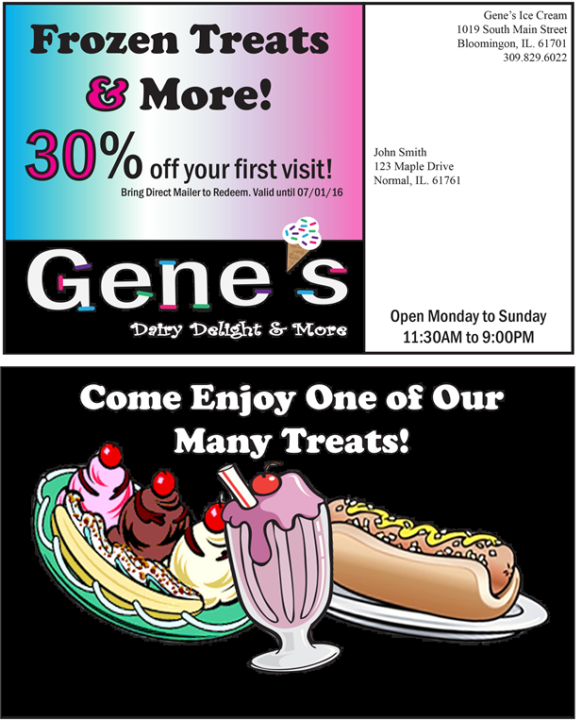

**Exhibit 5**

**Reward Card (Front to Back)**

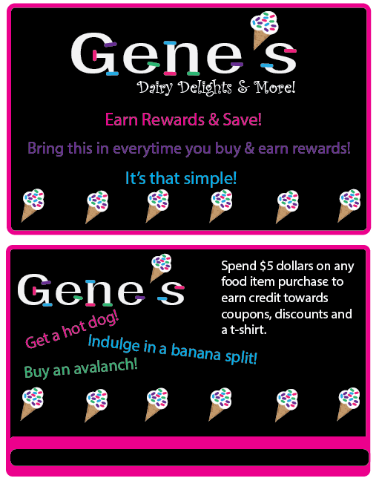

**Door Hanger:**

When creating the door hanger layout for Gene’s I took into consideration our goal to raise awareness (primarily among the secondary target- college students). Based on this consideration, the focus of the door hanger is to emphasis location and store hours, rather than to promote a coupon or event; which will be a focus in our other layouts. When designing the hanger I made the overall color scheme, match Gene’s original colors with a focus on pink and blue. I choice to create a hole (for the door handle) to be in the shape of a scoop of ice cream to emphasize Gene’s core product, and to add flare to the design. I then chose to differentiate the size and font of the header, “Join us for Frozen Treats & More” to draw the eye to Gene’s products, for those who have not heard of the company. I specifically changed the “&” symbol to a different color to emphasize that Gene’s offers more than just ice cream. To finish the door hanger, I included our logo at the bottom corner to create fluency among the other layouts.

**Magnet:**

The magnet is going to be handed out to its target audience to increase brand awareness about the new and improved Gene’s. The magnet’s main purpose is to send a reminder towards the target audience to satisfy their cravings of delicious ice cream after dinner or on a hot sunny day. The Magnet reminds the target audience by providing the address of where Gene’s is, their business hours that they are open till with phone number, and social media platforms to remind them to follow them for upcoming deals on their next purchase so that drives customers to come back for more ice cream and develop brand loyalty. The colors of the magnet show an even blend of bright colors of blue, white and red. These bright colors show the perfect blend combination for the target audience, where it’s the main theme for promoting ice cream and be family friendly. The logo form is also the logo type because it shows the name of the business along with a creative font containing bold black lettering. Along with containing an assortment of colors that resemble sprinkles of ice cream on the edges of each letter of the name, and containing a detailed ice cream cone as the apostrophe of the name to show the novelty of ice cream. It’s simple but effective enough for the target audience to recognize the main purpose of trying to capture attention from another room in a person’s living space or home. The positioning statement explains that Gene’s sells a variety of ice cream and also explaining that it sells more than just ice cream that it also sells food.

**Exhibit 6**

**Door Hanger**

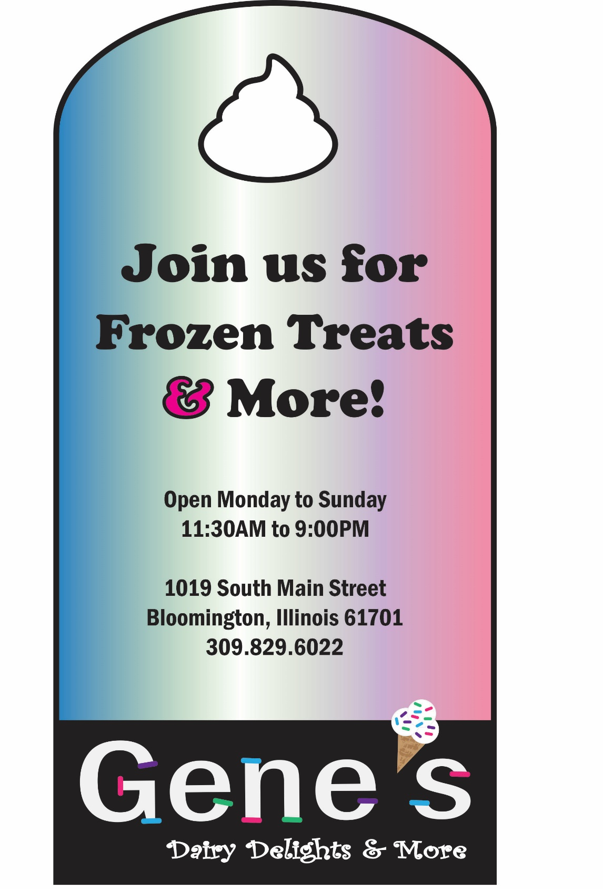

**Exhibit 7**

**Magnet**

**T-Shirt:**

Our idea for the Gene’s t-shirt layout is to stick with the color scheme of our logo. We really wanted to appeal to Bloomington families by really making the colors pop, but not making it to obnoxious. We feel that children will really be drawn to having this due to its colorful nature. We also think it would be great for Gene’s to display these t-shirts in the windows of their ice cream shop to really appeal to consumers. We were also thinking that these t-shirts could be a “prize” for consumers who have the reward card. After 20 purchases over $5, they will receive this t-shirt for free. The system will track this and make sure that no customer receives more than one t-shirt. The t-shirt will also be available for people who do not want to be involved in the reward card and will cost $20 to purchase. We feel that this t-shirt also appeals to our secondary market due to the fact that college students love free t-shirts. We personally think no matter what the t-shirt says a college student will wear it. We do realize that this is very colorful and may be a little over the top, but whenever a consumer thinks of an ice cream shop (especially mom and pop shops) they think colorful and bright. We did not want the back of the t-shirt to be plain, so we added a simple map of how to get to Gene’s from main St. We wanted to keep the back simple but yet colorful to still attract people’s attention. We also feel that if there are any community events Gene’s should go and promote themselves with flyers, the t-shirt, and maybe coupons. Overall we were trying to make the logo stick in the mind of consumers, and create awareness whenever someone wears it.

**Exhibit 8**

**T-Shirt**

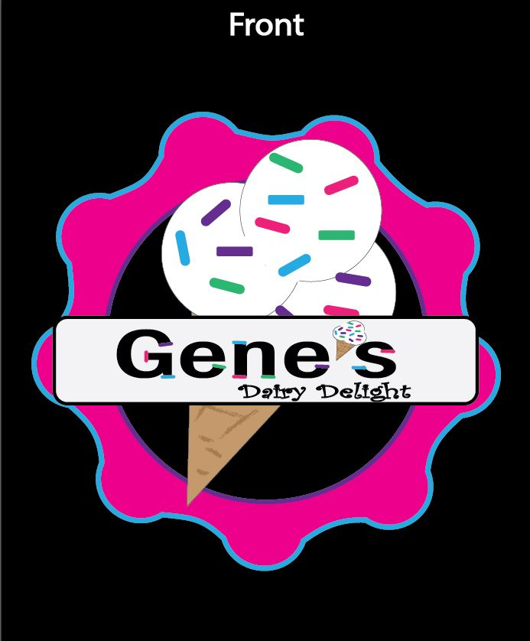

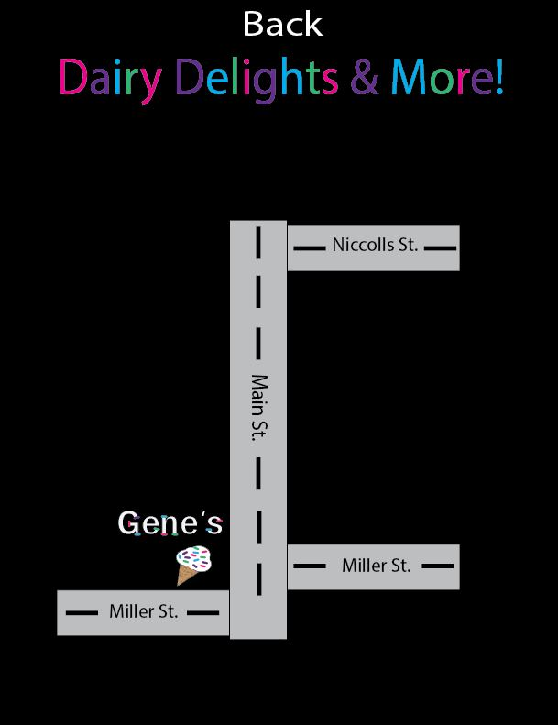



Appendices

32| Page



Appendix A:

In-Depth Interview

Method & Results

33 | Page

**In–Depth Interview**

Our team interviewed 23 members from our target audiences. There were 16 from our primary target audience and 7 from our secondary target audience. We concluded from our in-depth interviews that many people are aware of Gene’s, and only one person had Gene’s as a top-of-mind stop for treats.

The goal of our interview was to find out how aware of Gene’s our target audiences are. Refer to Exhibit A-1 for the interview script. After organizing our results from our interview we found that the results varied greatly from our primary audience to our secondary audience. The most important factors for our primary audience were low price and quality, and for our secondary the most important factors were close distance and low price. They both agreed that low price was an important factor but Bloomington residents were more concerned about quality rather than the distance.

**Where does our target audience go for desserts/treats?**

A very important factor we were trying to get from our in-depth interview is where our target audiences are going for tasty treats. We found that most marked Insomnia Cookies, Dairy Queen, and Carl’s Ice Cream. Our primary audience claimed that Dairy Queen and Carl’s Ice cream were popular places for their families to go, but our secondary target usually preferred Insomnia Cookies. We believe this has to do with the distance. Insomnia is more conveniently located for students, since it is in uptown normal. Since only one of our target audience members said they would go to Gene’s for treats, we realized we really needed to put our primary focus on awareness and recognition.

**How do our target audiences pick where to go for desserts/treats?**

Another important thing we wanted to learn about our target audiences, is how they choose where they are going to go for desserts/treats. We were wondering if it was influenced by their friends, other family members, social media, or advertisements. We found out that the primary way our target audiences choose where to go is by word of mouth. If a friend/family member recommends a place they are more likely to go to that place. Some also stated that they have seen advertisements via commercials or radio advertisements that persuade them to go to that place for a dessert/treat. The local dessert or treat places are primarily advertised through the radio and the larger chain places are advertised through television. This is difficult to compare because many people change the radio station when commercials are playing. Although DVR is on the uprising we believe that people still view more advertisements on the television versus hearing them on the radio. Since we are focusing on building awareness understanding how people are hearing about place is crucial. This can ensure that we use the correct methods in our campaign. We believe that once Gene’s becomes part of our target audiences evoked set they will recommend it to their friends and this will greatly increase traffic and awareness.

**Exhibit A-1**

**In-Depth Interview**

Hello my name is _________. I am an ISU student working on a class project. We are interviewing people to get a better understanding of their preferences about local businesses. This interview has just a few questions and will take about 5 minutes to complete. Your name or any other identifying information will ***not*** be recorded and the results will be aggregated or summarized for the group not reported individually. We would appreciate your help. Do you have a few minutes?

**Screening**

* Are you a parent of young children?
* Are you a student of either ISU, Illinois Wesleyan, or Heartland Community College?

**Awareness**

* Please list all of the local ice cream places in Bloomington and Normal, IL that come to mind.

**Behavior I & Preferences**

* How many times a week do you go out to get dessert or treats?
* List the places you would usually go to in order to get a dessert or treat.
* List the factors that go into you choosing a place for dessert or treat. (Rank them in importance)
* Where are your favorite place to go for desserts or treats and why?
* How far would you travel to get quality desserts or treats?
* Do you have a car that would allow you to travel this distance?

**Awareness II & Perceptions**

* Which of the following have you heard of. [read list of competitors and our client]

(Please indicate Very, Somewhat, of never heard of)

* For each of the places listed, please describe your impression of them.

**Exhibit A-1 (Cont.)**

|  |  |  |  |  |
| --- | --- | --- | --- | --- |
| Place | Very Familiar | Somewhat Familiar | Not at all | Perception |
| Gene’s |  |  |  |  |
| Carl’s Ice Cream |  |  |  |  |
| Dairy Queen |  |  |  |  |
| Sweet Temptation Cupcake |  |  |  |  |
| Cold Stone |  |  |  |  |
| Emack & Bolio’s |  |  |  |  |
| Insomnia Cookie |  |  |  |  |
| Cookies by Design |  |  |  |  |
| Cherry Berry |  |  |  |  |
| Orange Leaf |  |  |  |  |

**Exhibit A-1 (Cont.)**

* If not heard of Gene’s, how likely would you go there? [read description of Gene’s]

**Behavior II**

* What should Gene’s do to raise awareness of their place?
* Have you gone to Gene’s website? [if have heard of Gene’s]
* What are some way you heard about local dessert or treat places?
* What type of social media do you often use?



Appendix B:

Copy Test

Method & Results

38 | Page

**Copy-Test Results**

**Copy Test Method:**

The copy test method for Gene’s was made to see the effectiveness of the direct mailer that we will send out. We interviewed 6 representatives from our primary and secondary audience and asked them to recall the name of the brand, what the message of the mailer is, and if the mailer gave them an idea of what Gene’s sells.

The two layouts that were shown to the interviewees were very similar but they both had a different message. The differences between the two was that back of the direct mailers. One had some ice cream with words of what Gene’s offered and one had actual pictures of what Gene’s offered. The front of both the copy tests were the same because we believe that did not need to be changed. Both flyer A and flyer B offered a 30% off coupon to Gene’s.

This copy test was conducted by the four members of our group and we each interviewed two people each. All the respondents were shown direct mailer A and asked questions, and then they were shown direct mailer B and shown questions. We gave each respondent about 2-3 minutes to look at the copy tests because we believed that was a good amount of time for some time to look quickly and recall most information. The questions that were asked for both flyer were the same, and the respondents were asked at the end to choose with direct mailer they liked the best and what they would change.

**Direct Mailer Copy Test Results:**

After interviewing six people of the primary and secondary target market we found that most could recall from direct mailer is the 30% coupon, the colorfulness and the ice cream. For direct mailer b they could only recall the 30% off and the hot dog & banana. For direct mailer A, 5/6 remember what brand the ad was for and for direct mailer B 6/6 remembered what brand the ad was for. We believed we received high results for this because we have the logo front and center on the front of the direct mailer. For direct mailer A people liked the colorfulness, the ice cream and the font, some disliked the color scheme and the words were too distracting. For direct mailer B people liked the colorfulness, the font and the food, some disliked the words on the front.

Overall, we believe that layout and information on both the direct mailers were effective. After all of the results, we decided to take people’s opinions and just make a whole new direct mailer. We knew that the colors were distracting so we decided to add a black background yet still keep the different types of food on the back. Even though flyer A was liked the most we believe that the new one we made will be very effective in the future.

**Exhibit B-1**

**Copy Test A**

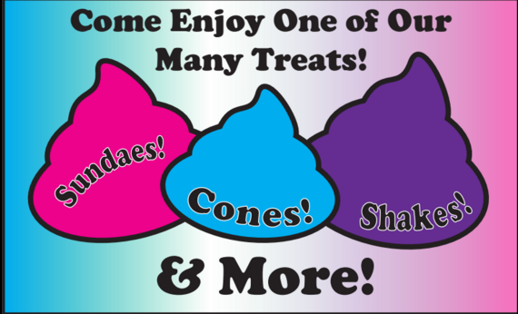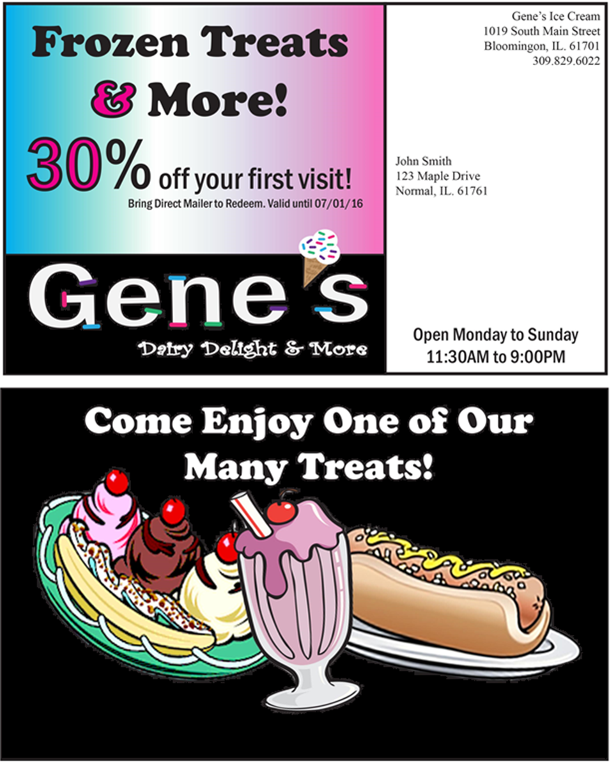

**Exhibit B-2**

**Copy Test B**

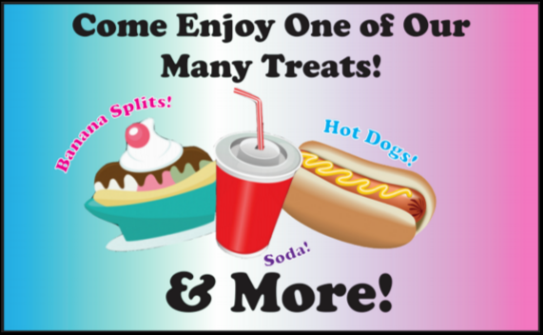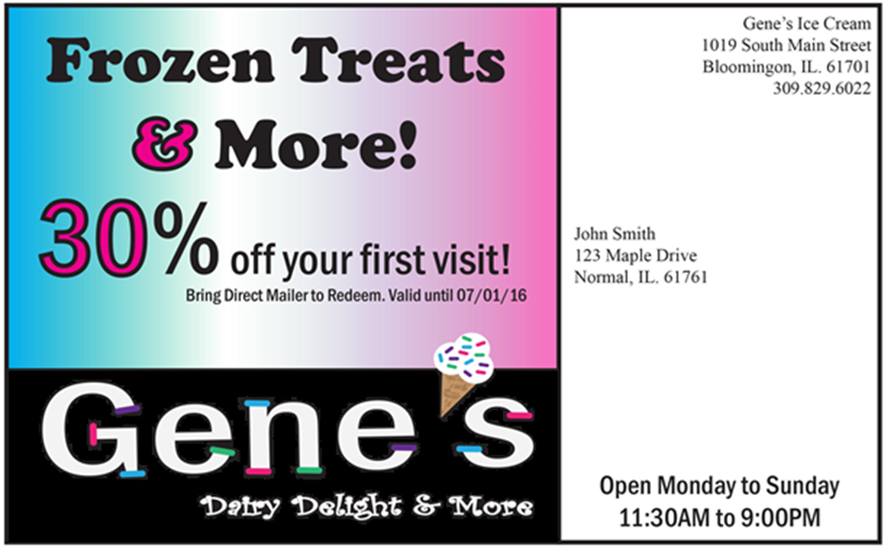

**Exhibit B-3**

**Copy Test Script**

Hello ……, we want to take a few minutes of your time to please look at an ad that we have created. After you get a chance to look at ad and the questions, we would like to get your opinion on it.

[Show Direct Mailer A. Give person around 2-3 minutes to look at.]

1. Please recall everything you remember about this ad

1. Please list the business this ad was for.
2. Please describe what you think the main message of this ad was
3. How likely are you to go visit this company?
4. Does this ad give you an idea of what this business sells?
5. (Show Direct Mailer A again) What did you like or dislike about the ad?

Now that you have seen the first ad, I am going to show you another ad that we have made.

[Show Direct Mailer B. Give person around 2-3 minutes to look at.]

1. What did you like or dislike about this ad?
2. Which ad do you prefer overall?